Spring Boot Note
Source : https://www.youtube.com/watch?v=1993zSY5UBI&list=PLA3GkZPtsafacdBLdd3p1DyRd5FGfr3Ue
(0 TO 5)
@RestController
- Used in Spring Boot to create REST APIs
- Tells Spring that this class will handle web requests
- Data returned by methods goes directly to the client (JSON / String)
- No need to use @ResponseBody
@GetMapping("")
- Used to handle HTTP GET requests
- Connects a URL to a method
- "" means base URL (/)
- When this URL is accessed, the method runs
Example
@RestController
public class myClass {
@GetMapping("abc")
public String sayHello(){ //method
return "Hello World";
}
}
Output:
http://localhost:8080/abc → Hello World

Tomcat started on port 8080 (http) with context path '/' our apis getmapping name

port 8080 so localhost:8080 and then context path '/' so localhost:8080/abc
if context path has something then like '/project' then localhost:8080/project/abc

(6 NO. Video)

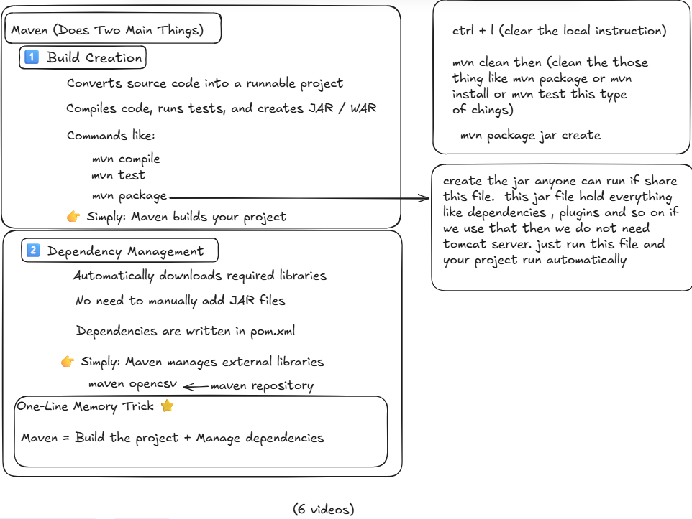
(7 NO. Video)
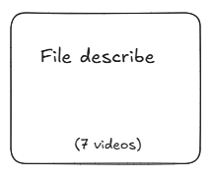
(8 NO. Video)

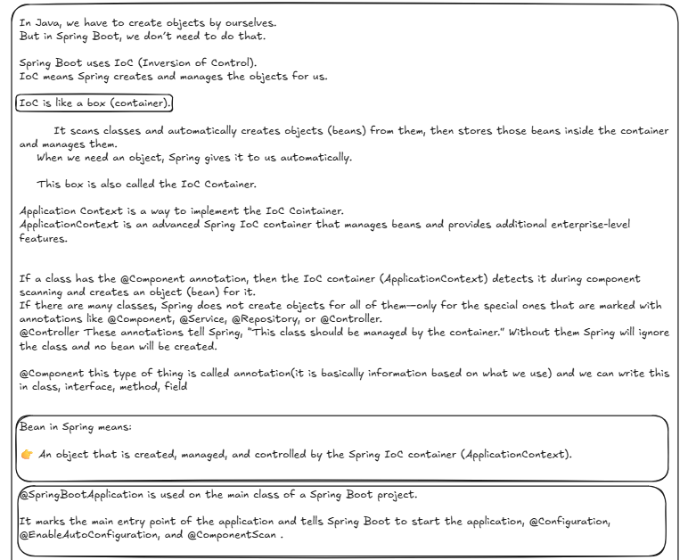
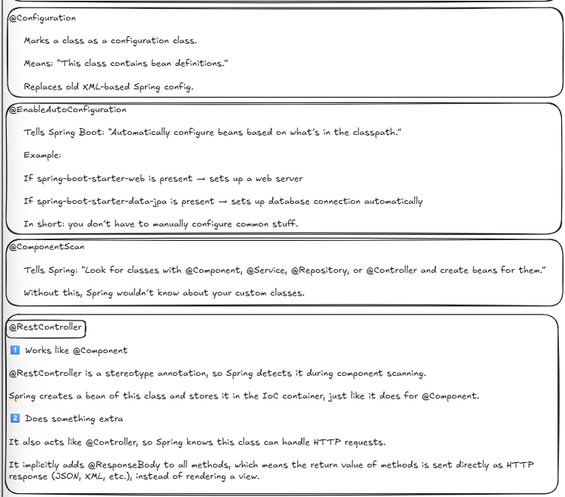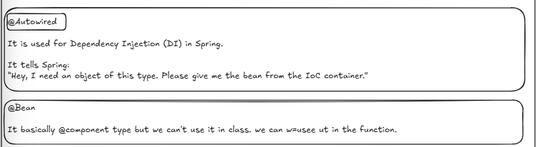

(9 NO. Video)
Rest api (Representational State Transfer Application Programming Interface) handles web server requests. First of all, I need to know the URL & I also need one thing, which is the HTTP Verb. It is basically GET, POST, PUT, DELETE
Get -> Only Watch that
Post -> =Create Something
Put -> Modify something
Delete -> Can delete something
So Rest Apis Basically (URL + HTTP Verb)

@RequestMapping(“/a”)
Here I can add @GetMapping(“check”) post put delete
If I want to hit then I have to write a then check like: localhost:8080/a/check

private Map<Long, JournalEntry> journalEntries = new HashMap<>();
What it is?
- A Map that stores your data in memory
- Long → key (usually an ID)
- JournalEntry → value (your data object)
- Think of it like a tiny fake database

public List<JournalEntry> getAll() {
return new ArrayList<>(journalEntries.values());
}
Why return List<JournalEntry>?
REST APIs usually return:
- A single object → get by id
- A list of objects → get all
So “get all journal entries” naturally returns:

new ArrayList<>(journalEntries.values())
Points to remember:
- journalEntries is a Map
- A Map stores data as key → value
- journalEntries.values() gives only the values
- values() returns a Collection, not a List
- Our method return type is List<JournalEntry>
- Java does not allow returning Collection when List is expected
- new ArrayList<>(...) converts Collection into List

@RequestBody
Take the Data from the request and turn it into a java Object that i can use it in my code.
It’s use basically postmapping, for example:
@PostMapping
public boolean createEntry(@RequestBody JournalEntry myEntry){
journalEntries.put(myEntry.getId(), myEntry);
return true;
}

@GetMapping("id/{myId}")
public JournalEntry getJournalEntryById(@PathVariable Long myId){
return journalEntries.get(myId);
}
Suppose we want to watch something using that id number so that’s why "id/{myId}")
Here it’s pathVariable so we need to write @PathVariable Long myId. myId can be changed. @DeleteMapping also work like this

